Sprint Report 1
Portfolio task 2/3/4
Unit code: COS40005
Unit Name: Computing Technology Project A
Submission date: 19/04

Acknowledgment of Country
Each team member identifies the Traditional Owners of the land they lived on while completing this work (if living in Australia)…
Kumarawadu Dinith Thejana:
I, Kumarawadu Dinith Thejana, acknowledge the Wurundjeri People of the Kulin Nation,
who are the Traditional Owners of the land on which SwinburneAustralian campuses are
located in Melbourne east and outer-east, and pay our respect to their Elders past,
present and emerging.and recognise their enduring connection to Country, culture and
community. I am committed to honouring this land and the peoples whose knowledge and
traditions have shaped it since time immemorial.

Minh Hoang Duong:

I, Minh Hoang Duong, acknowledge the Wurundjeri People of the Kulin Nation,
who are the Traditional Owners of the land on which SwinburneAustralian campuses are
located in Melbourne east and outer-east, and pay our respect to their Elders past,
present and emerging.and recognise their enduring connection to Country, culture and
community. I am committed to honouring this land and the peoples whose knowledge and
traditions have shaped it since time immemorial.

Kaveesha Dharmadasa
I Kaveesha Dharmadasa acknowledge the Wurundjeri People of the Kulin Nation,who are the Traditional Owners of the land on which SwinburneAustralian campuses are located in Melbourne east and outer-east, and pay our respect to their Elders past,present and emerging.and recognise their enduring connection to Country, culture and community. I am committed to honouring this land and the peoples whose knowledge and traditions have shaped it since time immemorial.
Ved Jay Makhijani
I, Ved Jay Makhijani, respectfully acknowledge the Wurundjeri People of the Kulin Nation, who are the Traditional Owners of the land on which Swinburne’s Australian campuses are located in Melbourne’s east and outer-east, and pay our respect to their Elders past, present and emerging.

Contribution summary (This Sprint)

All team members should complete the following table together. You can provide a yes/no response or a brief comment where appropriate.

 | Contribution | Initiatives | Communication |  |  |  |  |  | Respect
Team Member | Finished tasks in time or on time with an acceptable quality | Self-assigned tasks and proactively found solutions to problems | Attended all team meetings | Attended all supervisor meetings |  | Attended all client meetings | Replied every time within an acceptable timeframe | Kept the team updated about the status | The student respected others and listened to different opinions
Ved Jay Makhijani - 104762184 | Yes – Completed PB6 (LLM instruction parser) fully: schema, prompts, edge cases, parser, 24/24 unit tests passing, and interactive demo working end-to-end, and Comparative Analysis of all models. | Yes – Self-selected PB6, designed the output schema independently, established shared interface contract for team, resolved Python 3.14/LangChain compatibility issues | Yes |  | Yes | Yes | Yes – Responded promptly via Teams and kept team informed of module status | Yes – Shared schema.py interface with team and pushed all code to GitHub with clear commit messages | Yes – Collaborative, supported teammates and listened to design feedback during meetings
Member 2
Kaveesha Dharmadasa  105271678 | Yes – Completed key tasks including vision framework research, JSON design, and architecture documentation on time with good quality | Yes – Took initiative in researching YOLO vs OpenCV, designed scene abstraction structure, and recommended LLM pipeline | Yes |  | Yes | Yes | Yes – Responded actively in team discussions and updates | Yes – Shared documentation and updates via repository and discussions | Yes – Maintained good collaboration and considered team input
Dinith Thejana  105231766 | Yes – Completed key technical tasks including development of vision output module, scene representation, and spatial relationship computation with correct JSON outputs. | Yes - took initiative to implement the full vision pipeline (detection → scene → relationships),structured JSON design, and tested outputs in VS Code. | Yes |  | Yes | Yes | Yes – Responded actively in team discussions and updates | Yes – Shared progress, code outputs, and GitHub updates with the team | Yes- Maintain good collaboration,support team member, and respected different ideas

Contribution Details (This Sprint)
In this section, every member of the team should write a summary of what they have contributed during this sprint. All contributions must be supported by evidence, such as the number of GitHub commits, a screenshot of developed screens, a summary/outcome of research, etc.

Team Member: Ved Jay Makhijani (104762184)

During Sprint 1, my primary responsibility was PB6 — the LLM Instruction Parser Module. This module is the entry point of the entire AI pipeline, responsible for converting natural language user instructions into structured JSON that all downstream modules (scene representation, task planner, execution) consume. I completed this ticket in full and it is the most technically complex individual deliverable of Sprint 1.

Task 1: LLM Module Setup and Project Structure (PB3 – LLM research slice / PB6)
I selected GPT-4o via the OpenAI API with LangChain as the orchestration framework, based on a comparative evaluation of available models against criteria of JSON output reliability, latency, and integration ease. I initialised the llm_module/ folder with a clean modular structure: schema.py (Pydantic output model), parser.py (LangChain chain), prompts.py (system prompt and few-shot examples), edge_cases.py (pre/post processing), hello_world.py (connection test), demo.py (Sprint 1 demo script), and __init__.py (package entry point). I also set up the project’s GitHub repository folder structure and configured environment variable loading via python-dotenv.
- llm_module/ folder structure in VS Code file explorer showing all files
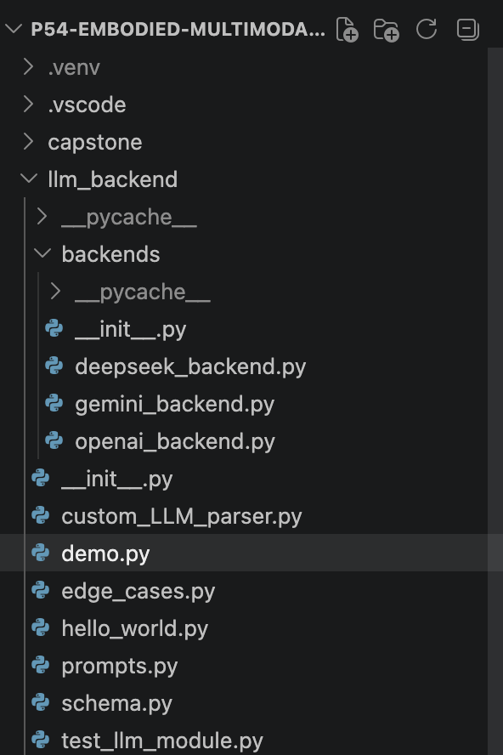

- GitHub repository showing the initial commit with llm_module folder and all files
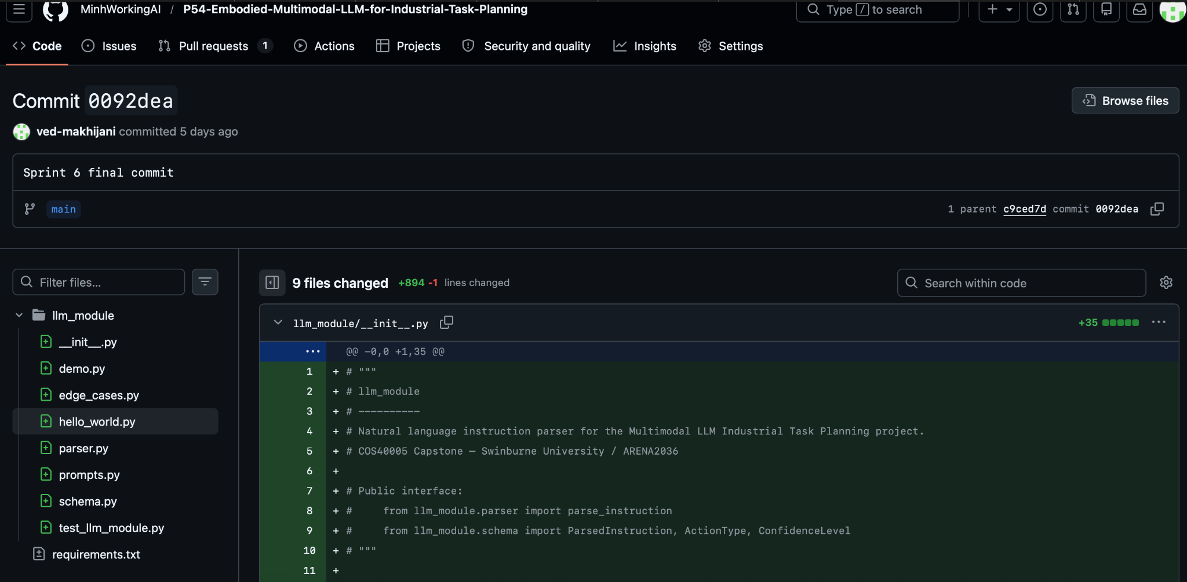

Task 2: Pydantic Output Schema Design (PB6)
I designed the ParsedInstruction schema using Pydantic v2, which defines the strict contract between my module and all downstream consumers (PB5 scene representation, PB7 task planner). The schema enforces four allowed ActionTypes (pick, place, move, locate) via an Enum, three ConfidenceLevels (high, medium, low), and fields for object_target, destination, spatial_relation, raw_instruction, and notes. I documented this schema and shared it with the team as the formal interface agreement — no other module is permitted to modify it without team consensus.
- schema.py code showing the ParsedInstruction Pydantic model, ActionType enum, and ConfidenceLevel enum
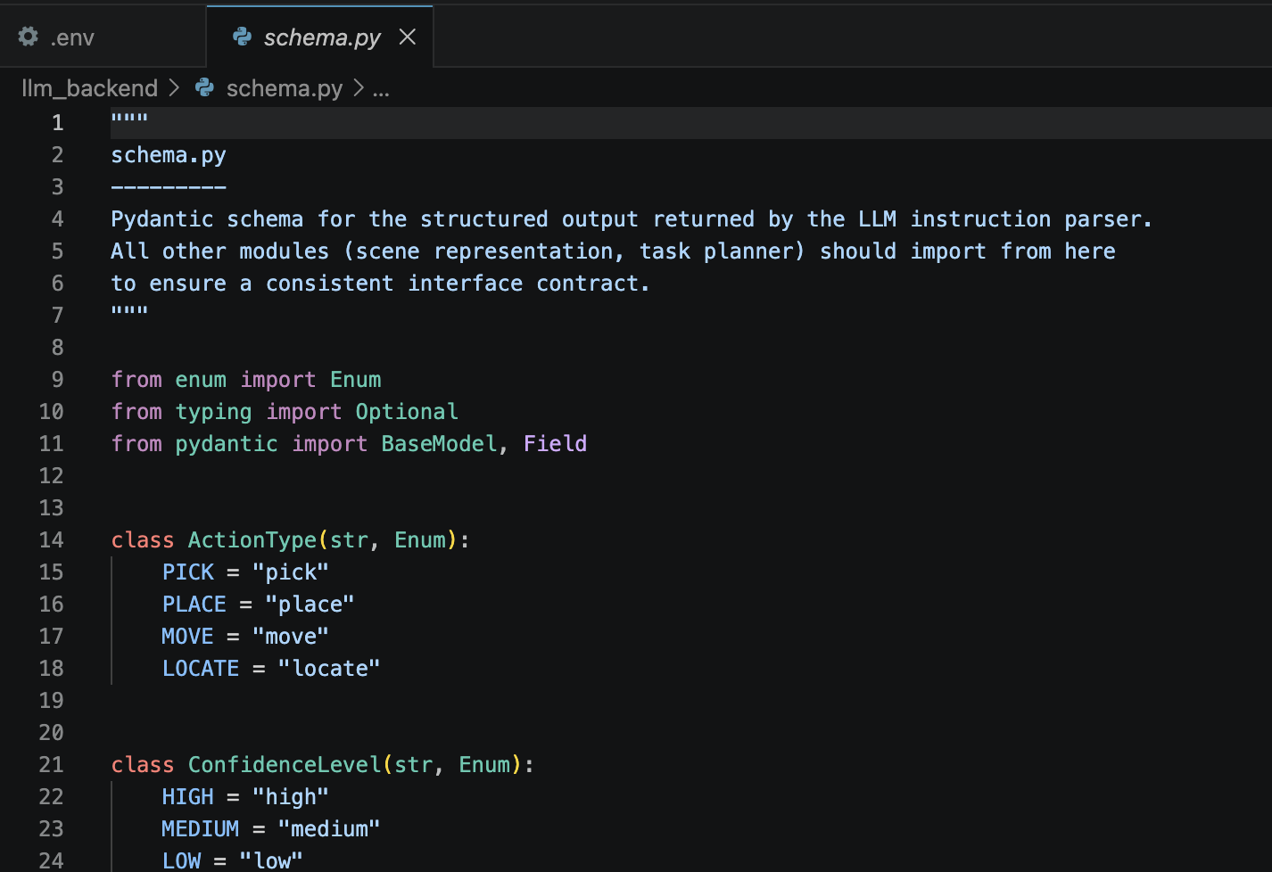

Task 3: Prompt Engineering and Few-Shot Examples (PB6)
I wrote and iteratively refined the system prompt in prompts.py, incorporating six few-shot examples covering: simple pick instructions, place with destination and spatial relation, synonym mapping (“grab” → pick), ambiguous instructions (low confidence), and multi-part instructions. Temperature was set to 0.0 to maximise output determinism. The prompt enforces that the model must always return valid JSON matching the schema, explicitly lists the four allowed actions, and requires that ambiguous instructions be flagged with a confidence of “low” and an explanatory note.
- prompts.py showing the system prompt template and the six few-shot example input/output pairs

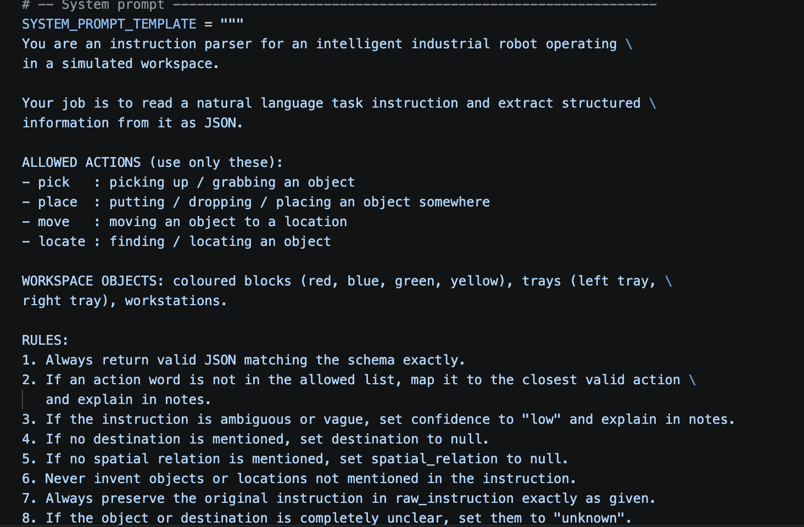
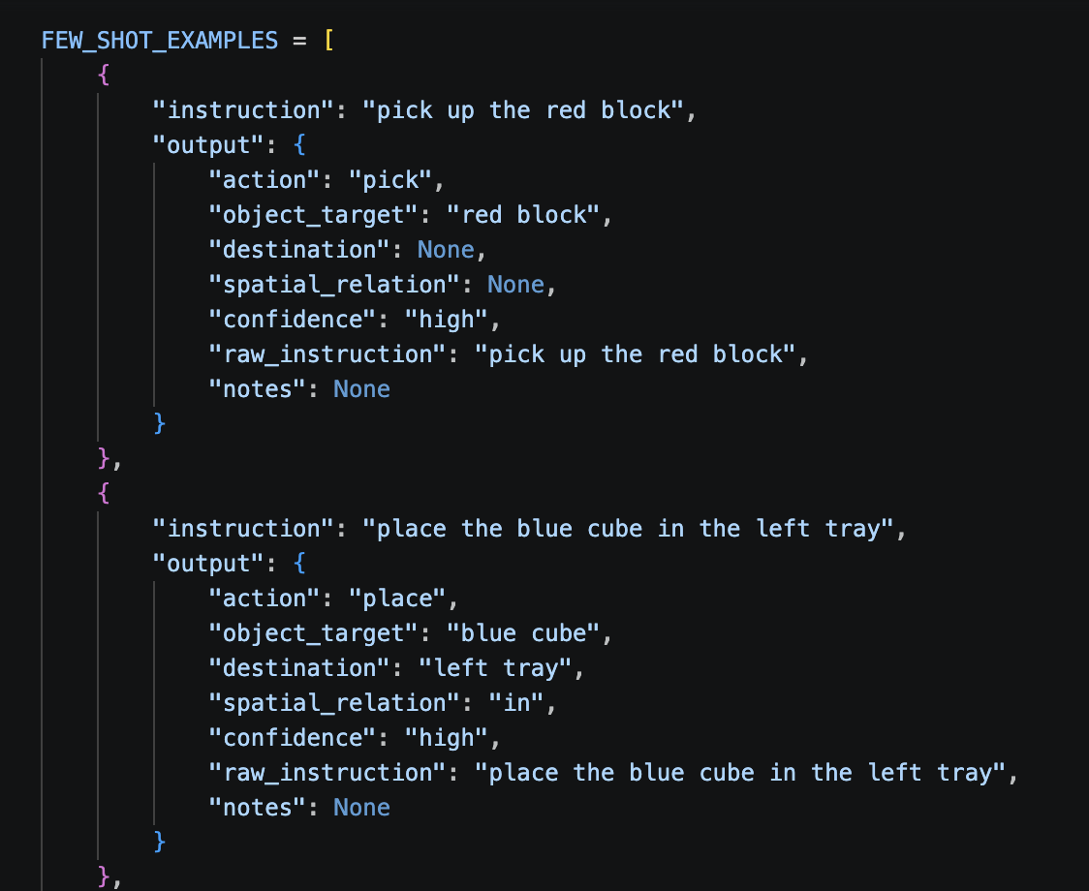
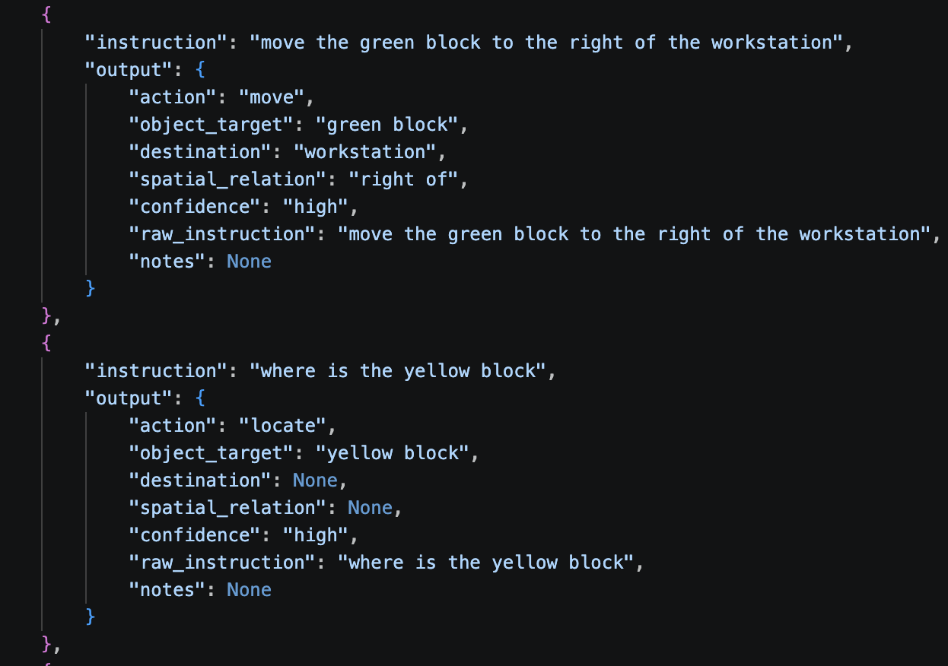
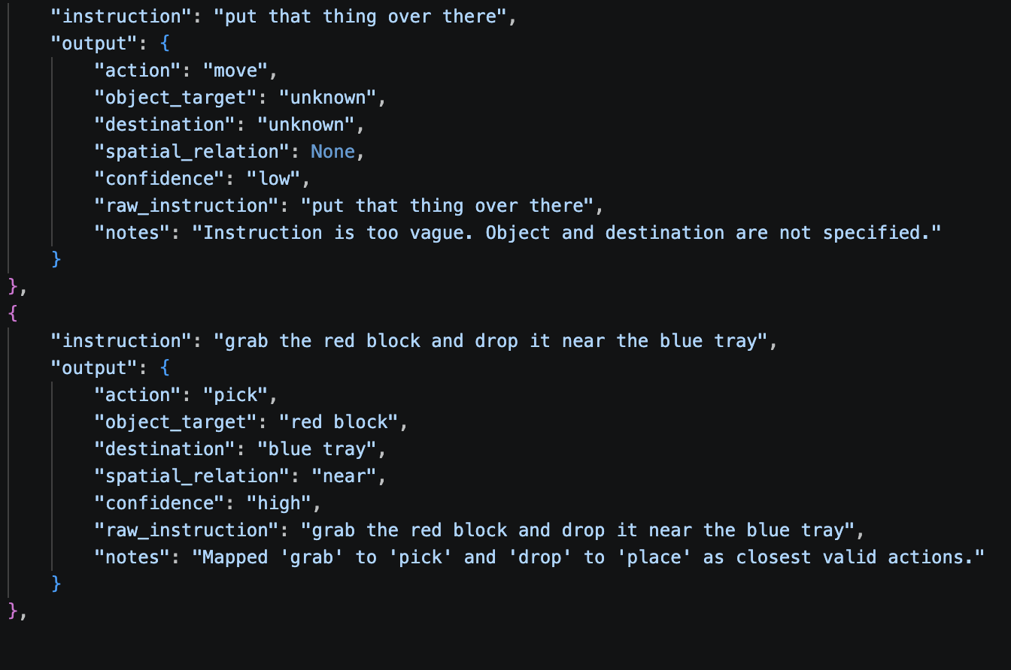

Task 4: Edge Case Handling (PB6)
I implemented edge_cases.py to handle all abnormal inputs before and after the LLM call. Pre-processing functions detect empty/whitespace instructions (raises ValueError immediately), vague instructions with no recognisable objects or actions (short-circuits the API call and returns a low-confidence result without wasting tokens), and normalise whitespace. Post-processing functions validate the returned ParsedInstruction, downgrade confidence to low if object_target or destination is “unknown”, and append explanatory notes. An action synonym dictionary (grab→pick, drop→place, find→locate, etc.) guides the LLM toward valid actions.
- edge_cases.py showing the is_too_vague(), normalise_instruction(), and validate_parsed_result() functions
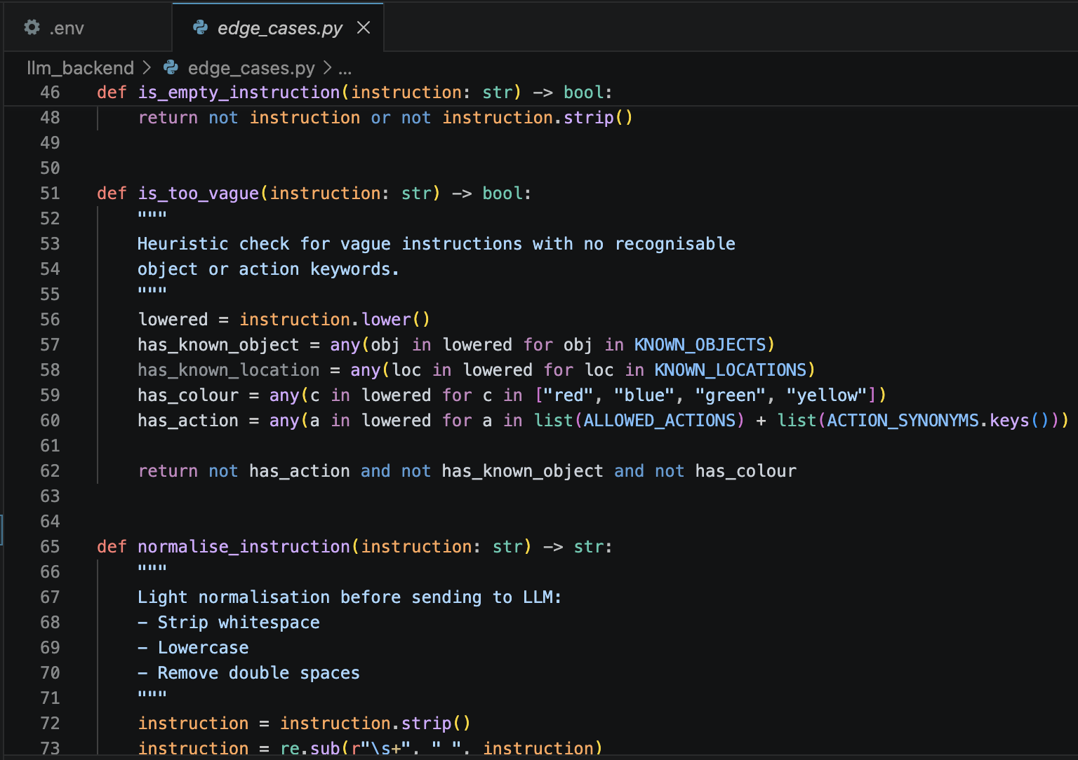

Task 5: Unit Test Suite – 24/24 Passing (PB6)
I wrote a comprehensive test suite in test_llm_module.py with 35 tests organised into three classes: TestSchema (6 tests — validates Pydantic model accepts valid inputs and rejects invalid action types), TestEdgeCases (18 tests — covers all pre/post processing functions without any API calls), and TestParserIntegration (11 tests — real LLM calls, marked with @pytest.mark.integration and skipped without API credits). Running pytest test_llm_module.py -v -m "not integration" yields 24 passed with 0 failures. This means all core module logic can be verified by any team member at any time, even without an API key.

- Terminal showing pytest output: 24 passed, 0 failed, 11 deselected (integration tests skipped)]
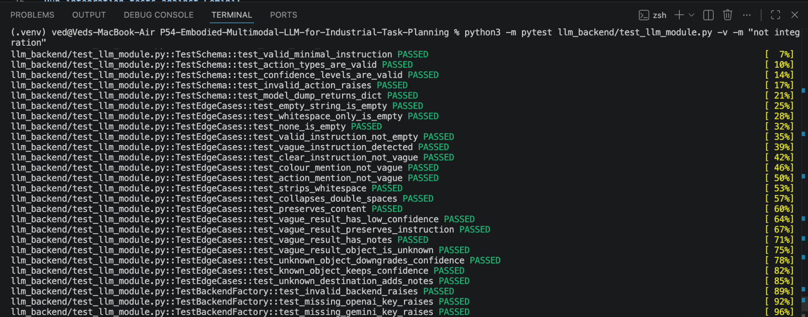

Task 6: Demo Script and End-to-End Verification (PB6)
I built demo.py with two modes: a preset demo (python demo.py) that runs six representative instructions and prints colour-coded JSON results, and an interactive mode (python demo.py --interactive) for live demonstration. I verified the module end-to-end against the OpenAI API, confirming that all four instruction types (simple, spatial, synonym, ambiguous) were parsed correctly on the first attempt with correct action, object, destination, spatial relation and confidence fields returned.
- Terminal showing demo.py --interactive output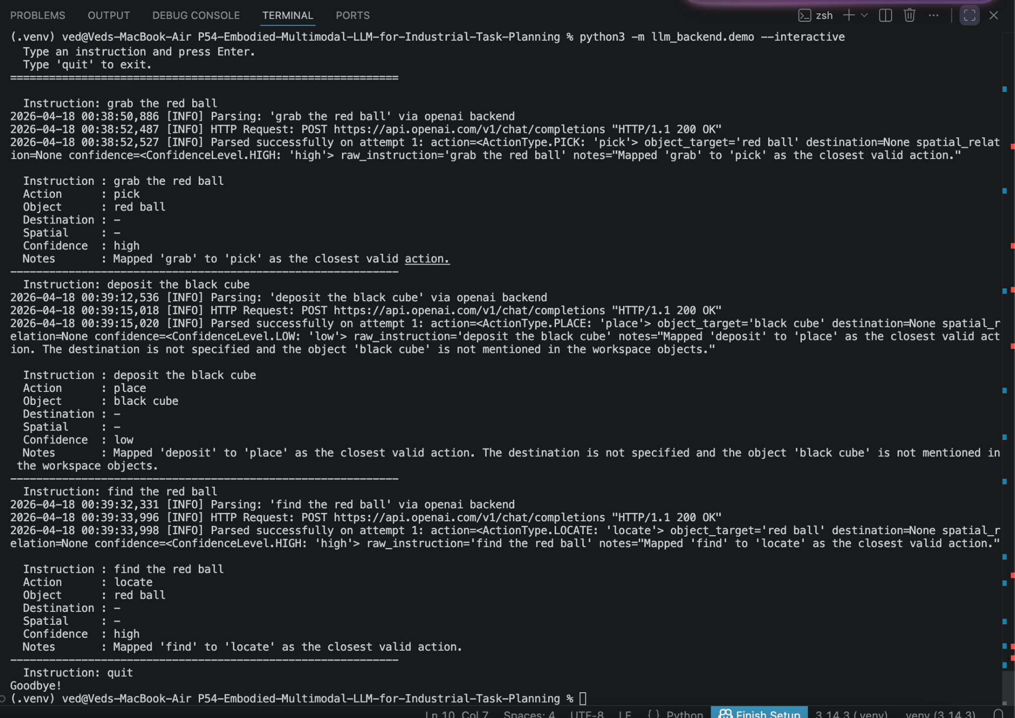

Task 7: Comparative LLM Evaluation Results
The table below summarizes the performance of the three evaluated models across 25 test instructions.
Metric | GPT-4o | DeepSeek | Gemini
Instruction Accuracy (%) | 76.0 | 76.0 | 56.0
Parse Success Rate (%) | 100.0 | 100.0 | 84.0
Action Accuracy (%) | 100.0 | 100.0 | 76.0
Object Accuracy (%) | 96.0 | 96.0 | 80.0
Destination Accuracy (%) | 96.0 | 96.0 | 80.0
Spatial Accuracy (%) | 84.0 | 84.0 | 72.0
Avg Latency (ms) | 1,149.6 | 3,805.9 | 10,475.8
Error Rate (%) | 0.0 | 0.0 | 16.0

Key Findings by Category (Instruction Accuracy %)
- Simple Instructions: All three models (GPT-4o, DeepSeek, and Gemini) achieved 100.0% accuracy for basic single-action commands.
- Spatial Reasoning: GPT-4o and DeepSeek maintained 100.0% accuracy, while Gemini dropped to 80.0%.
- Edge Cases: GPT-4o and DeepSeek both achieved 75.0% accuracy. In contrast, Gemini failed significantly in this category with a 0.0% success rate and a 100.0% error rate.
- Multi-Step Tasks: Complexity impacted all models, with GPT-4o and DeepSeek at 66.7% and Gemini at 33.3%.

Analysis and Recommendations for Sprint 1
- Model Selection: GPT-4o is the recommended primary model due to its high accuracy and superior speed. It recorded the lowest average latency (1,149.6 ms), which is critical for real-time robotic execution.
- Gemini Performance Issues: Gemini's high average latency (10,475.8 ms) and failure to handle edge cases make it less suitable for the current pipeline requirements.
- Latency Impact: The significant latency in Gemini (peaking at over 22 seconds in some cases) could delay the robotics module testing process, similar to the hardware compatibility issues already identified.
- Future Plan: While GPT-4o is currently the most reliable for complex reasoning, the team will continue to investigate local, open-source models as backups to adhere to Australian Privacy Principles (APPs) for future real-world data handling.

Team Member: Kaveesha Dharmadasa. (105271678)
This sprint involved my main technical contribution that included filling the gap between the initial research phase and the system architecture design. I managed to accomplish three significant tasks, which are to document the tool choice of the perception , Find and Compare Vision Frameworks and language modules and to design the core scene abstraction data structure.

1. Document Findings and Recommendations on Tool Selection (Task ID: PITPP-9) According to the comparative analysis that the team did, I finalized and documented the architectural recommendations to the project:
· Vision Framework Recommendation (YOLOv8 + OpenCV): I suggested using YOLOv8 as the main object detector because of its high accuracy and speed in object recognition and generating the manufacturing components and bounding boxes in the correct position. OpenCV will be kept as a secondary coordinate mapping tool and pre-processing camera feed and sending it to YOLO.
· LLM Pipeline Recommendation (OpenAI API with Local Fallback): In the first prototype, I advised to use the OpenAI API (GPT-4) because it is the most reliable zero-shot intent extraction in complex reasoning (ReAct prompting) at the moment. But to adhere to the Australian Privacy Principles as described in our ethical considerations, I wrote that a local, open-source model should be implemented as a backup in subsequent sprints to manage potentially sensitive factory instructions.
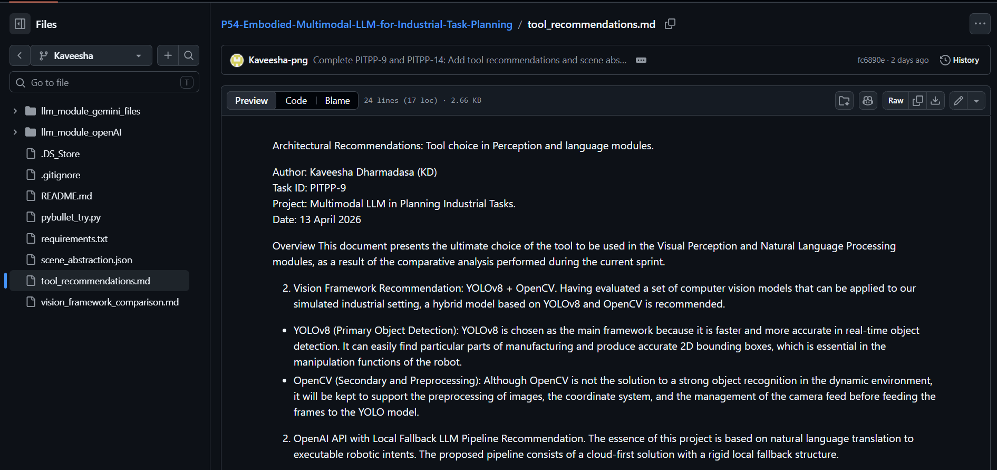

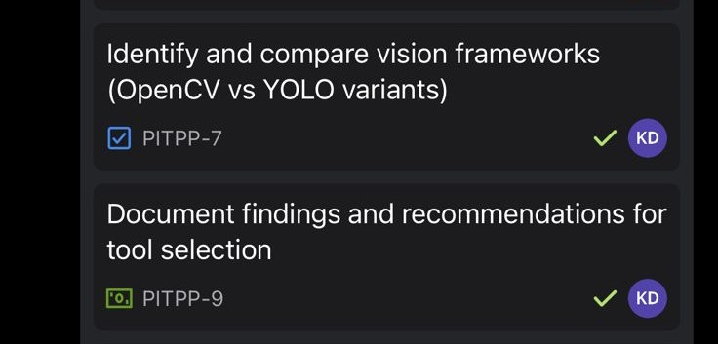

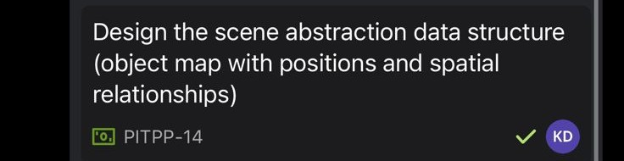
2. Design the Scene Abstraction Data Structure (Task ID: PITPP-14)
To allow the LLM Central Task Planner to get familiar with the physical environment, I developed a common JSON data format. This architecture is the crucial agreement between the Visual Perception module (object-detecting) and the Task Planner (action-generating). The structure generalizes the simulation environment into an object map with object IDs, physical attributes, 3D spatial coordinates and contextual relationships.
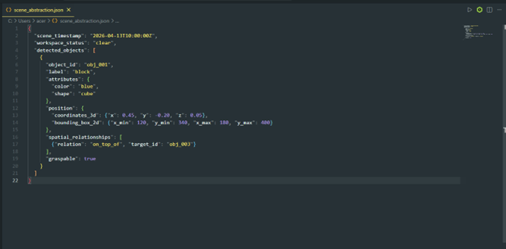
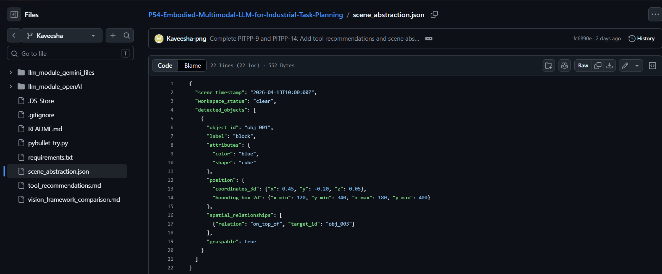
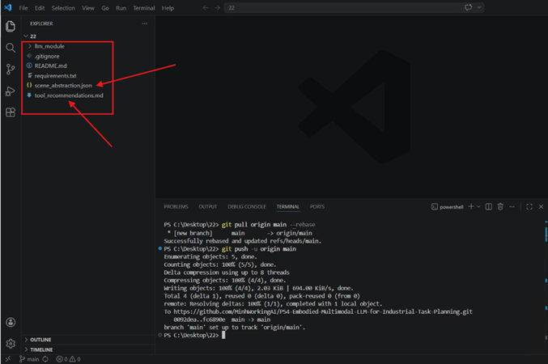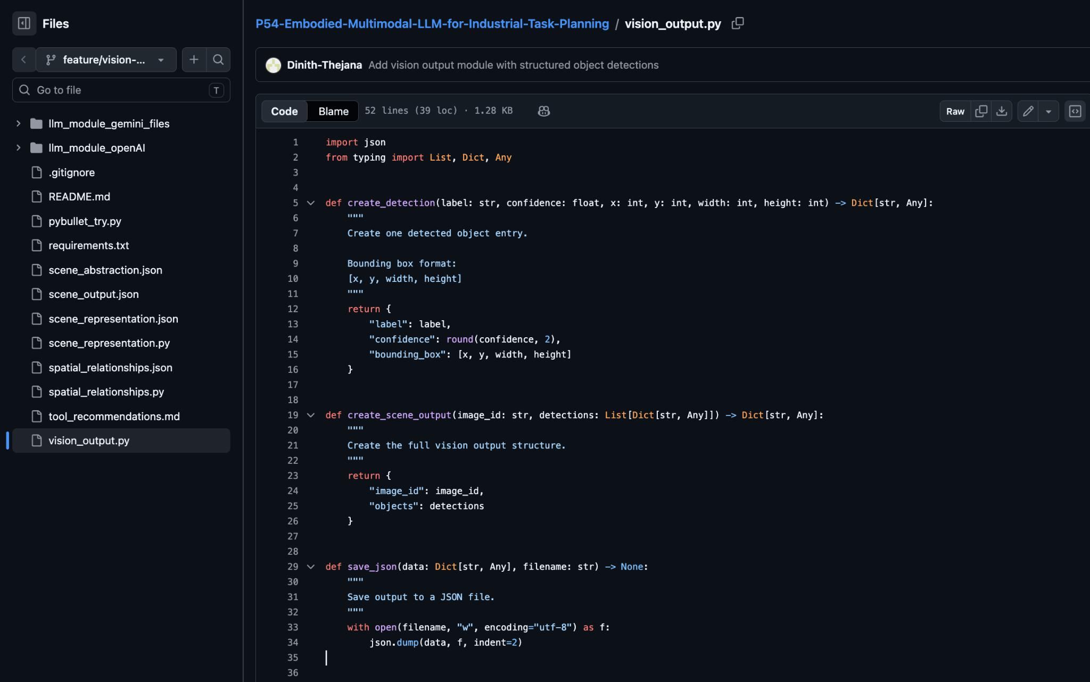
3. Find and Compare Vision Frameworks (Task ID: PITPP-7)
I assumed the role of researching the visual perception module to also assess the best framework to use in our industrial simulation. I performed the detailed technical analysis of the traditional computer vision (OpenCV) and object detection based on deep learning (YOLO variants). I compared these two frameworks on parameters like computational load, bounding box accuracy and classification robustness in dynamic environment. I saved these results in a comparative research markdown document (vision_framework_comparison.md) and added it to the repository, concluding that a hybrid YOLO-OpenCV strategy is obligatory to achieve precise abstraction of the scene with the help of LLM.
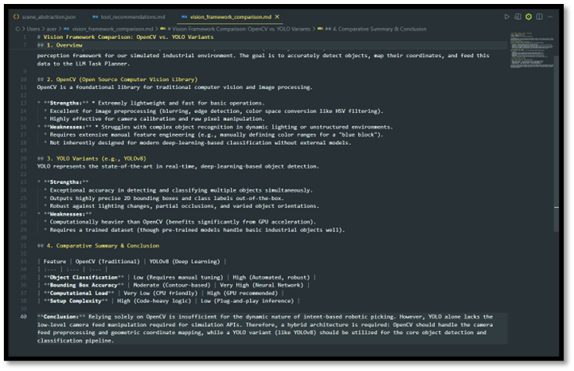
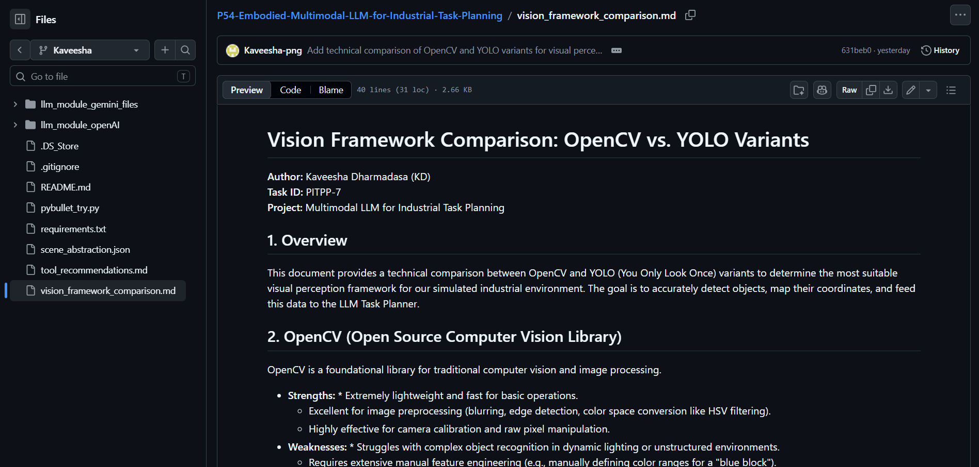
Team Member: Dinith Thejana. (105231766)
During this sprint, I contributed to the Vision Module development by completing PITPP-13, PITPP-15, and PITPP-16.
For Task PITPP-13 (Detected Object Output), I developed the vision_output.py module. In this task, I designed a structured JSON format to represent detected objects in the environment. Each object includes a label, confidence score, and bounding box coordinates. I created reusable functions such as create_detection() and create_scene_output() to ensure consistency and scalability. I tested this module using sample objects (red block, blue tray, green block) and successfully generated a valid scene_output.json file.
For Task PITPP-15 (Scene Representation), I implemented the scene_representation.py module. This module processes the raw detection output and transforms it into a more meaningful structure. I calculated the center point of each object based on bounding box values and organised the data into a structured scene format. This step is important because it simplifies the data for further reasoning tasks. The output was saved as scene_representation.json.
For Task PITPP-16 (Spatial Relationships), I developed the spatial_relationships.py module. In this task, I implemented logic to determine spatial relationships between objects, such as left, right, and near. I used object center coordinates to compare positions and applied Euclidean distance to identify nearby objects. This module generates human-readable relationships (e.g., “red block is left of blue tray”), which are useful for task planning and decision-making.
All three modules have been implemented within a basic pipeline where the result of one module acts as an input to the next module (Detection -> Scene Representation -> Spatial Relations). The complete implementation was done on my local system using VS Code and the results have been cross-verified for any errors in JSON logic or formatting.
Also, I was able to manage my task using GitHub by creating a separate branch in which I was able to commit my code without disrupting any other team member’s code.

Evidence:

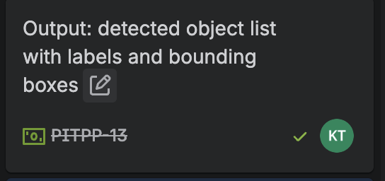
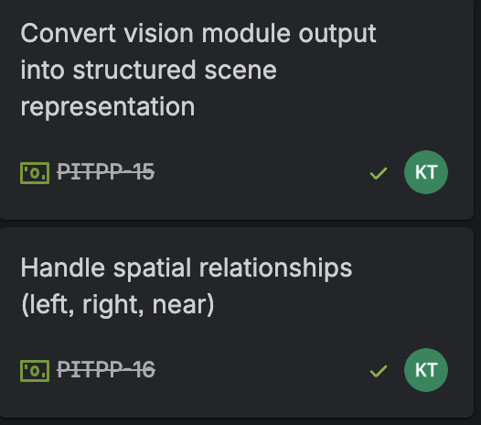
Figure 1: tasks completed: PITPP-13, PITPP-15, PITPP-16

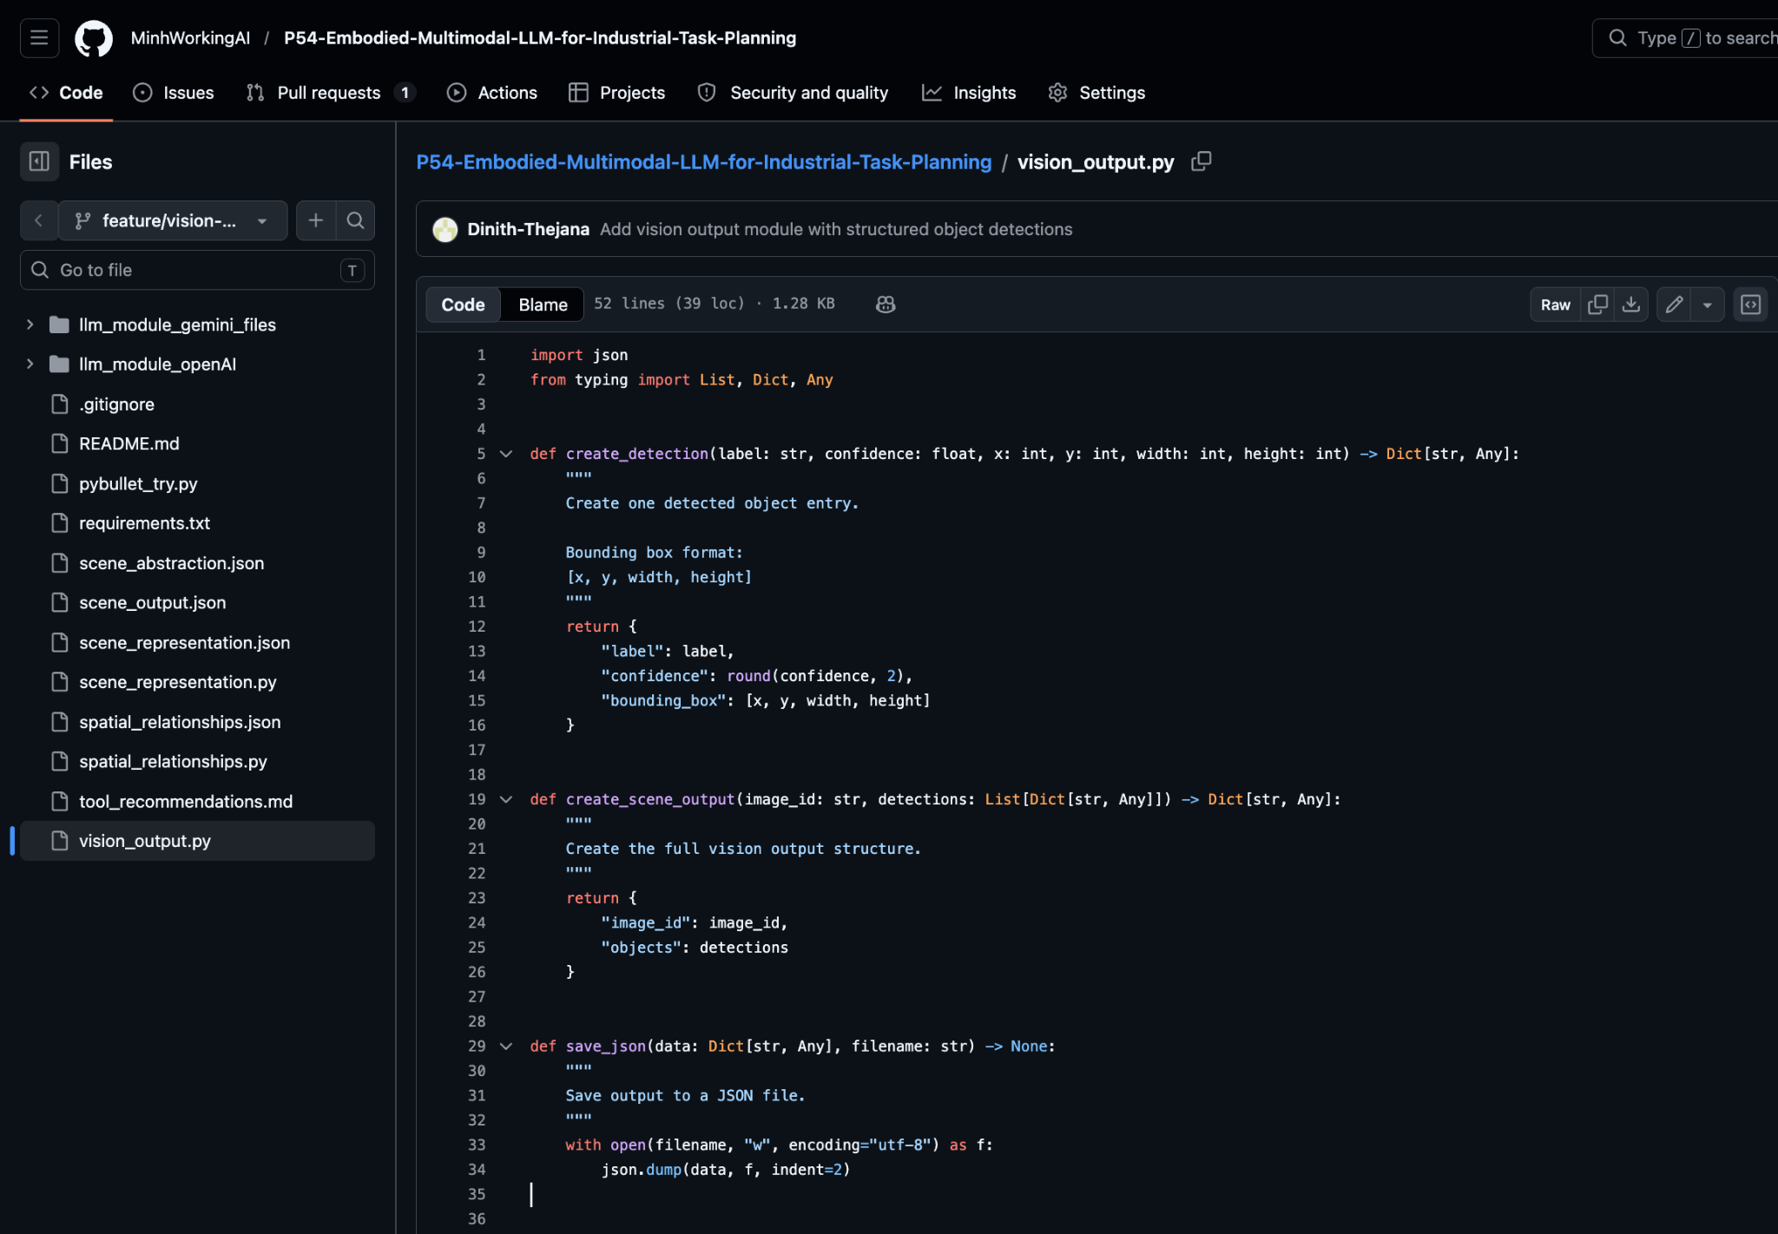

Figure 2: GitHub repository showing implementation of vision_output.py module with structured object detection output
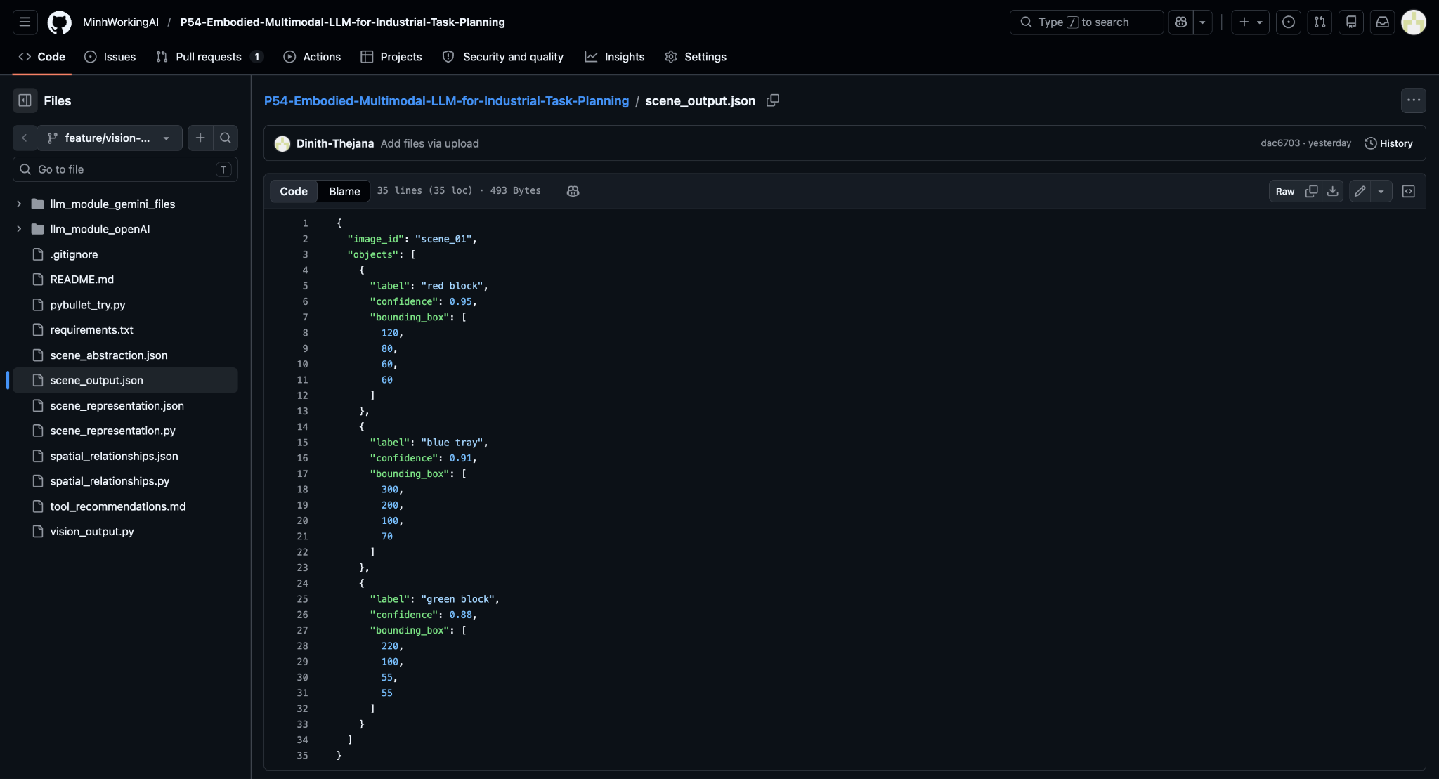
Figure 3: JSON output (scene_output.json) showing detected objects with labels, confidence scores, and bounding boxes generated by the vision module

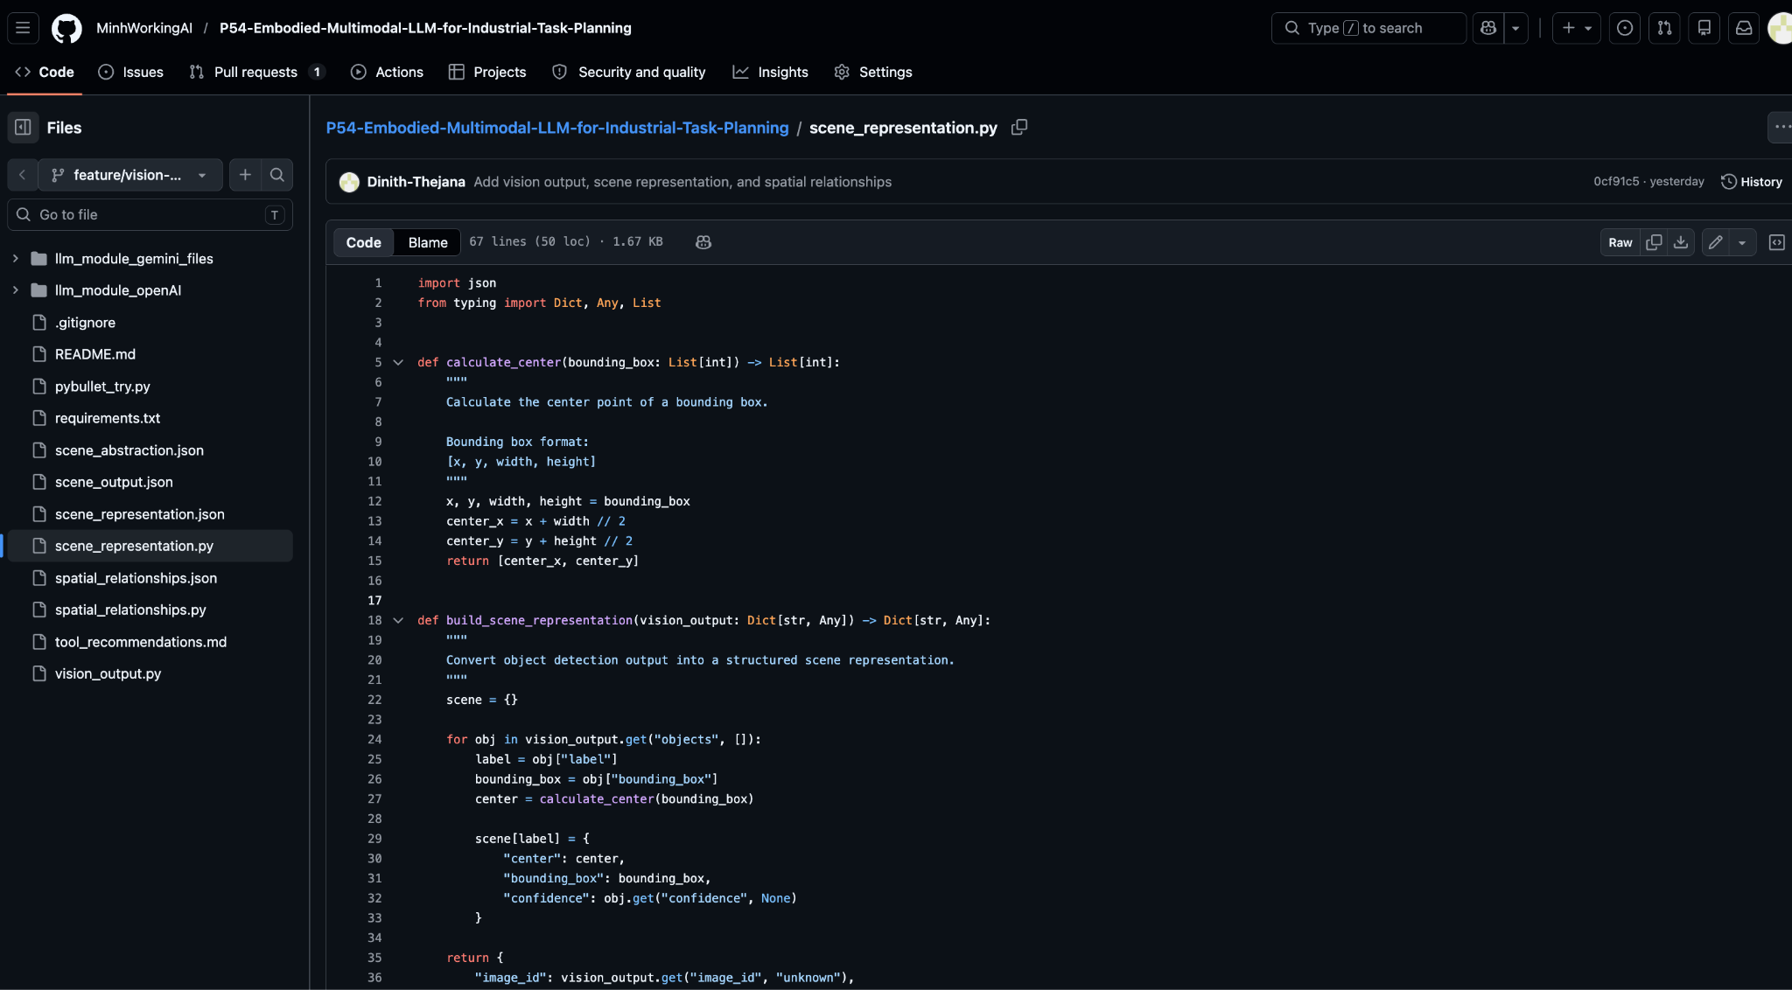
Figure 4: GitHub repository showing implementation of scene_representation.py module used to convert detection output into structured scene data

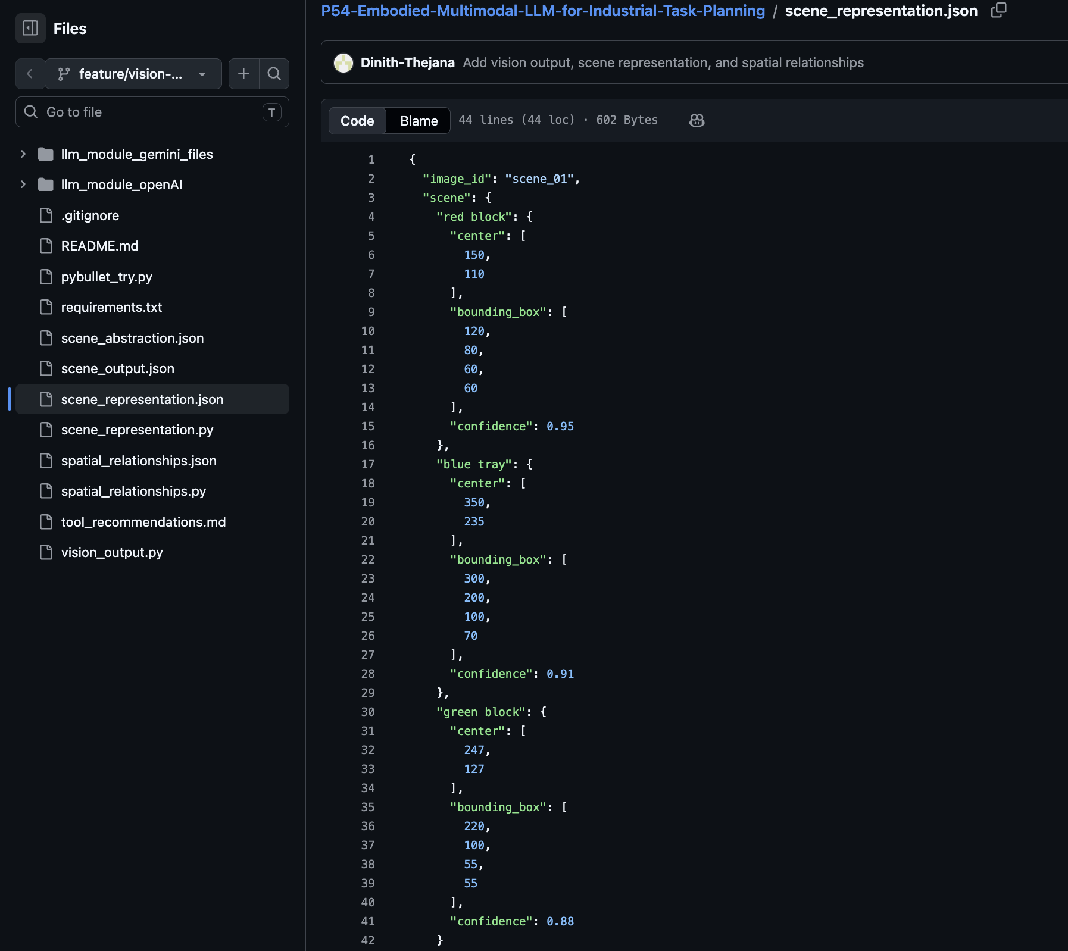
Figure 5: Structured scene representation (scene_representation.json) showing object centers, bounding boxes, and confidence values generated from the vision module output

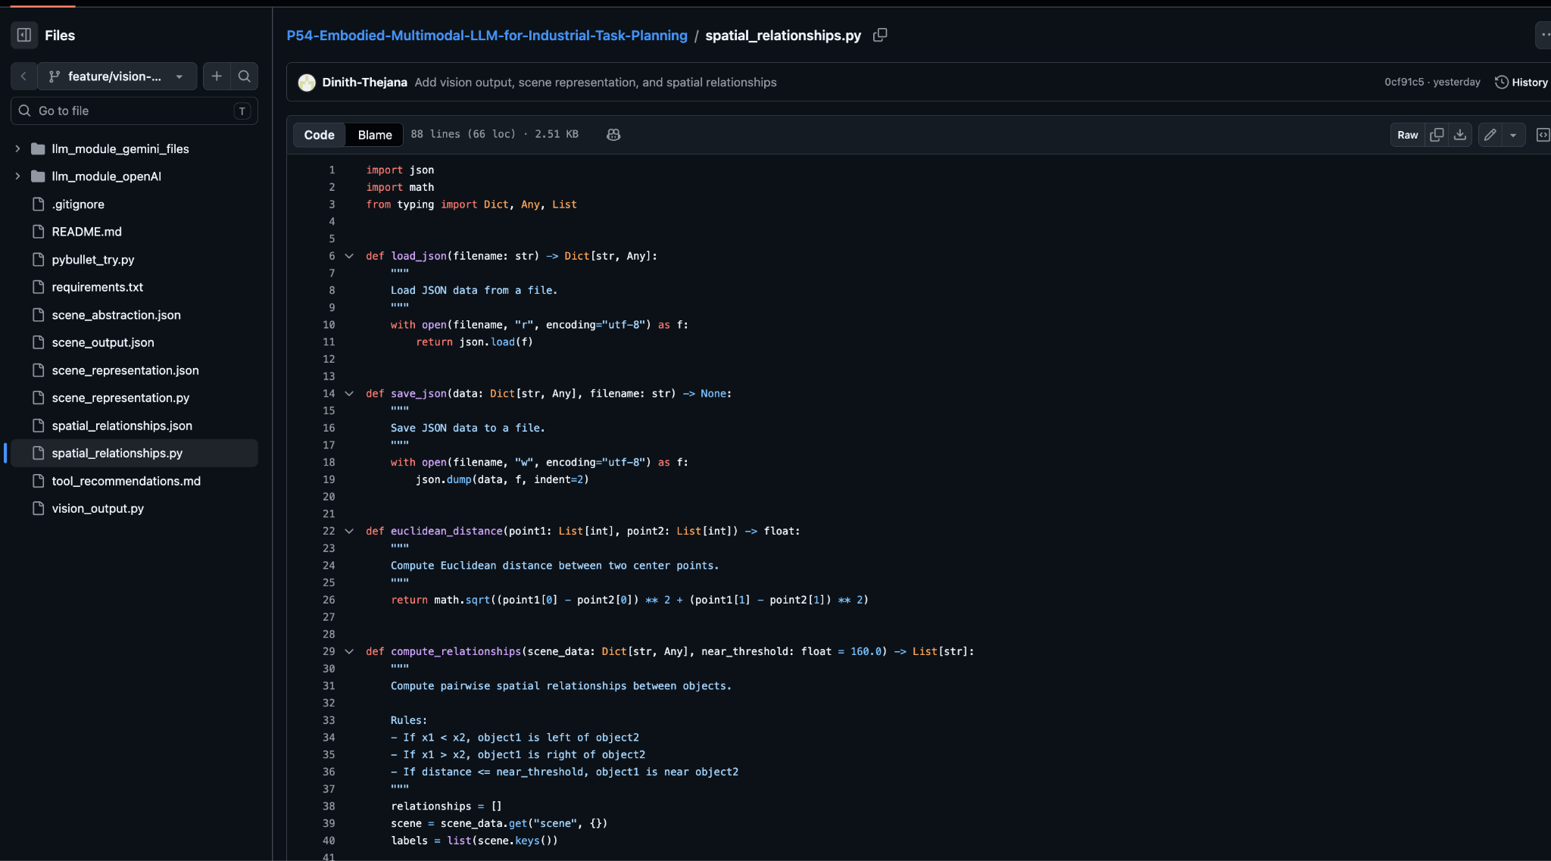
Figure 6: Implementation of spatial_relationships.py showing logic for computing left, right, and near relationships using object center coordinates
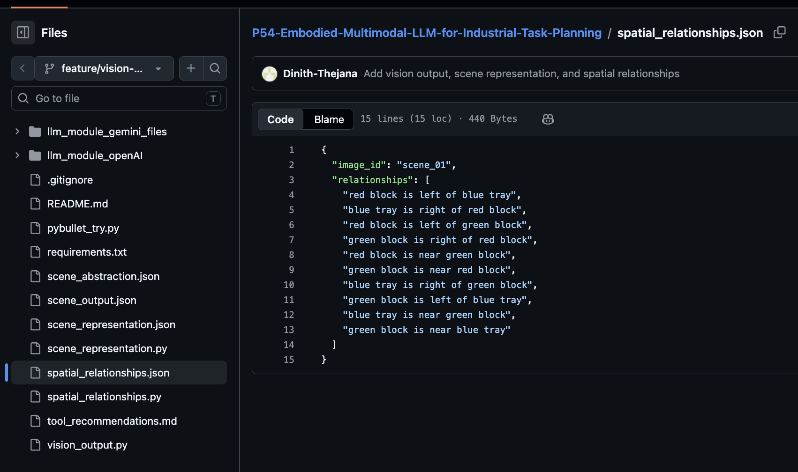
Figure 7: Spatial relationships output (spatial_relationships.json) showing positional relationships such as left, right, and near between detected objects

SPrint plan
Sprint Goal: The overall aim of Sprint 1 was to develop the underlying software architecture and provide the functional, standalone prototypes of the two main pillars of the pipeline the LLM Natural Language Parser and the PyBullet 3D Simulation environment.
Sprint Capacity: 5 Team members.
Sprint Backlog & Estimated Effort (By Epics):
Epic 1: System Architecture & Data Flow
* Repository Setup (2 Hours): Create the GitHub repository, create the Python virtual environment, and configure the modular folder structure.
* Vision Framework Research (PITPP-7) (3 Hours): A technical comparison of OpenCV and YOLOv8 to complete the visual perception architecture.
* Scene Abstraction Data Structure (PITPP-14) (4 Hours): Invent a standardized JSON schema to become the rigid communication contract between the Vision module and the LLM Task Planner.
Epic 2: Natural Language Processing (LLM Module).
* API Integration (3 Hours): Establish and implement secure integrations with OpenAI (GPT-4) and Google Gemini API to compare them.
* Prompt Engineering & Parsing (PITPP-19) (5 Hours): Implement the business logic to read unstructured natural language instructions and extract the structured intents (Action, Object, Spatial Relations).
* Edge Case Handling (PITPP-21) (3 Hours): Add unit tests (e.g., demo.py, edge_cases.py) to verify the ability to robustly interpret ambiguous instructions and avoid hallucinated arguments.
Epic 3: Robotics & Simulation
* Start PyBullet Environment (6 Hours): Load the simplest 3D physics world, including the robotic manipulator and objects of interest (e.g., blocks, trays) on the workspace.
* Configure Simulated Sensors (4 Hours): Configure virtual synthetic cameras to the simulation to effectively produce RGB data, Depth data and Segmentation Masks to be used in future vision processing.

Definition of Done (DoD) of this Sprint:
· Code and documentation are committed and merged to the main GitHub branch successfully.
· Without any fatal runtime errors, the LLM script can accept a string input and print a formatted JSON output.
· The simulation is successful with the robot and synthetic camera feeds visible and active.

SPrint progress
[This section describes the progress of the sprint with relevant evidence (e.g. screenshots of repository, task board etc). This section should clearly portray the team’s progress towards achieving the goal. The evidence can be discussed with the supervisor.]

Sprint review
[Add a detailed report on the following
- Description of the demonstration session outlining the facilitation process to indicate that professional conduct was displayed in communication with the client
- Feedback received from the client on the deliverable (must indicate if the increment was deliverable or not)
- A critical analysis of progress against the plans, particular progress achieved, challenges faced etc. for the deliverable]

Retrospect (Critical review of the process)
The group adopted an Agile process for the sprint by using tools such as Jira for tasks allocation and GitHub for software versioning. The tasks were allocated to individual members according to their duties, and progress was recorded after each meeting and update. Individual members were working on different modules and used different branches during coding.
The main strength of the group is that there were clear allocations of tasks and good teamwork. Every member played an important role in developing the software system by working on specific modules such as the LLM module and Vision module. There was consistency in communication within the group, and every member made updates during the sprint period.
There were several weaknesses that affected the work of the group during the sprint. One main weakness was integrating the modules because the modules were independently developed in the beginning. The group also faced some problems in working with GitHub because there were some problems with branching and authentication issues.
A problem encountered was dealing with unfamiliar technology, such as JSON structuring, spatial reasoning, and learning how modules fit together in the pipeline. The problem was solved by initially testing smaller parts individually before combining them into one system.

Another problem the team had was getting PyBullet to work on macOS devices because some of the members could not get the simulation environment to run. This delayed the testing process for the robotics module. Some possible solutions include looking for other ways to perform simulations, finding out what went wrong during the installation process, and using other team members' machines that work well.
In terms of ethics, the project takes into consideration data security issues and ethical usage of AI. In this case, data is currently simulated, but its future development might include data from the real world. Thus, the team recognizes the need for following Australian Privacy Principles (APPs) as it ensures secure handling of any data obtained through the course of the process. Furthermore, validating LLMs helps prevent misleading or erroneous results.
In general, the process went well, and necessary changes were implemented, and the team identified key challenges.

Lessons learned (Critical review of SPRINT one experience and future plan)
[Add a list of lessons learned from working together on the particular project in the group. List a clear set of to-do/recommendations for improvement in the future. Please note this should not be generic – it should be specific to this sprint.]

